SIMATS ENGINEERING
ASSESSMENT TOOL 1

COURSE NAME: INTERNET PROGRAMMING
COURSE CODE: CSA43

COURSE OUTCOME COVERED

CO-2 : Apply CSS layout and styling techniques to create visually appealing and responsive web interfaces, and use JavaScript to enable interactive client-side behavior. (L3)

Assessment Tool : Integrated Experiments

Weightage: 40%

QUESTIONS: Total Marks: 30

Code of Conduct:

I K. Lahari(192325118) (Name / Reg No) certify that this submission is my original work and that I have adhered to the guidelines specified for this assessment. I understand that any violation of academic integrity rules will result in disciplinary action.

Signature of the student: K. Lahari

Experiment 1: Responsive Layout Design
Question: Design a responsive retail webpage using Flexbox or Grid and media queries. Ensure proper alignment, spacing, and adaptation to mobile, tablet, and desktop screens.
Simple explanation: I created the NovaMart retail website. Flexbox aligns the header and navigation, while CSS Grid arranges the product cards. Media queries change the layout for different screen sizes. The page also includes Add to Cart and View Cart features.
(a) Analyze the reasons for lack of responsiveness.
Fixed widths, unsuitable margins, and missing media queries can cause content to overlap or overflow on smaller screens.
(b) Design a responsive webpage using Flexbox or Grid.
I used Flexbox for the header and navigation, and Grid for the product cards.
(c) Demonstrate adaptation to mobile, tablet, and desktop using media queries.
The desktop layout displays four product columns, tablet displays two, and mobile displays one column.
(d) Implement spacing, alignment, and distribution techniques.
I used padding, margin, gap, justify-content, and align-items to keep the page neatly spaced.
(e) Evaluate the design and suggest improvements.
The layout can be checked by resizing the browser. Further improvements include saving the cart after refresh and adding real checkout and payment features.
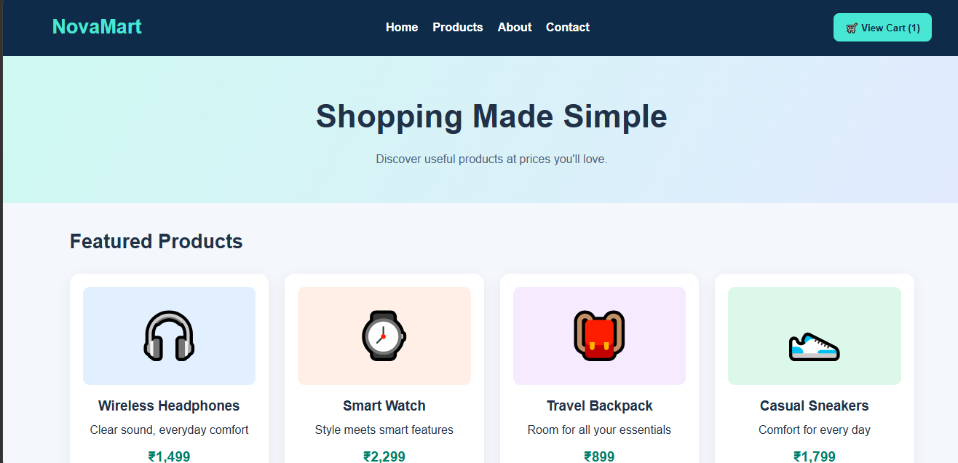
1: NovaMart responsive retail website with product cards and View Cart.

Experiment 2: Form Validation using JavaScript
Question: Validate email and phone number inputs using HTML attributes, JavaScript Regular Expressions, and real-time error messages.
Simple explanation: I created a registration form with name, email, and mobile number fields. JavaScript checks the input format and shows an error message when the email or phone number is invalid.
(a) Analyze issues in the existing validation mechanism.
Without validation, users may enter incorrect email addresses or phone numbers.
(b) Design input fields with appropriate HTML attributes.
I used email and telephone input types, required fields, and suitable input patterns.
(c) Implement JavaScript validation using Regular Expressions.
The email expression checks the basic email format. The phone expression checks for ten digits beginning with 6, 7, 8, or 9.
(d) Display real-time error messages.
The form displays an error under a field while its value is invalid and clears it when the value is corrected.
(e) Evaluate the system and suggest improvements.
I tested invalid and valid-looking inputs. Server-side validation and email or phone verification should be added for a real application.
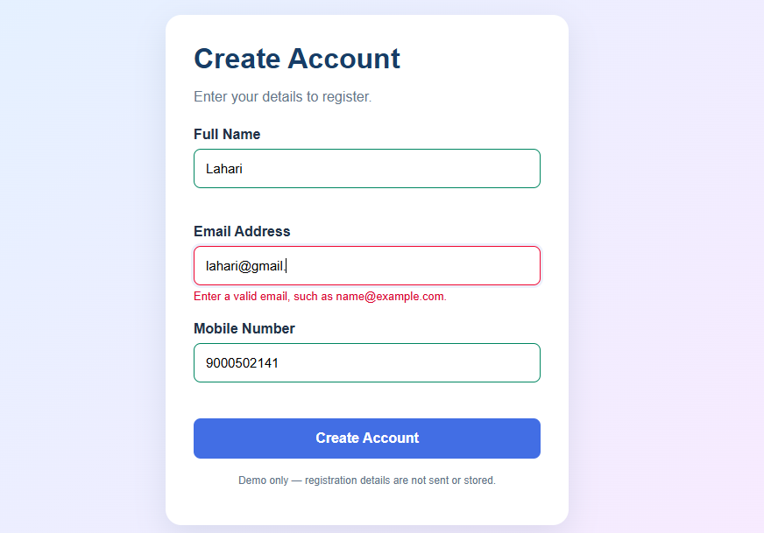
2: Registration form displaying an error for an invalid email.

Experiment 3: CSS Layout Debugging
Question: Identify and correct webpage overlapping issues using the CSS box model, positioning techniques, Grid or Flexbox, and responsive CSS.
Simple explanation: I created a dashboard with a sidebar and content cards. The page demonstrates a faulty layout and provides a button to apply the CSS fix. The corrected layout uses Grid, flexible widths, spacing, and media queries.
(a) Analyze CSS properties responsible for overlapping.
Fixed widths, excessive margins, and incorrect absolute positioning can cause elements to overlap.
(b) Explain the CSS box model.
The box model contains content, padding, border, and margin.
(c) Debug using suitable positioning techniques.
I used Grid and flexible sizing to arrange the sidebar and main content.
(d) Modify CSS to prevent overlapping during resizing.
Media queries stack the sidebar and content on smaller screens and reduce the number of card columns.
(e) Evaluate the corrected layout and suggest best practices.
I compared the faulty and corrected layouts and resized the browser. Responsive widths and consistent spacing help prevent layout problems.
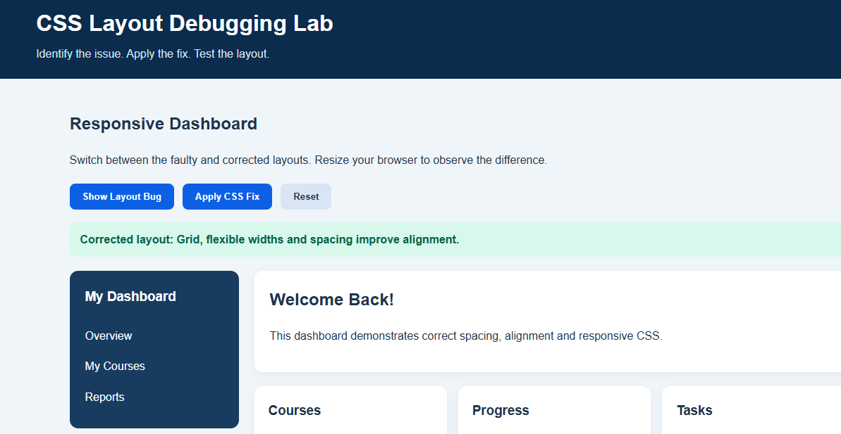
3: CSS Layout Debugging Lab showing the corrected dashboard.

